MONTCLAIR ART MUSEUM YARD SCHOOL OF ART
3 South Mountain Avenue, Montclair, NJ 07042
973-746-5555 montclairartmuseum.org
Life Drawing
Supply List
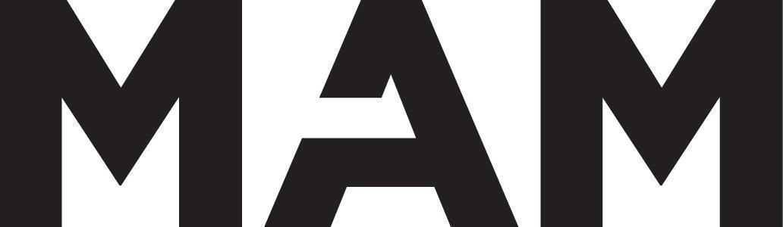
- 18x24 XL Canson Recycled pad
- Medium vine charcoal
- HB and 6B general’s charcoal pencil
- Pitts oil pencil soft, medium, and extra soft
- Kneaded eraser
- Hard white eraser
- An X-Acto blade with refills
All supplies except magazines, other papers, and glue sticks, are available at Jerry’s Artist Outlet in West Orange or online at Amazon or dickblick.

